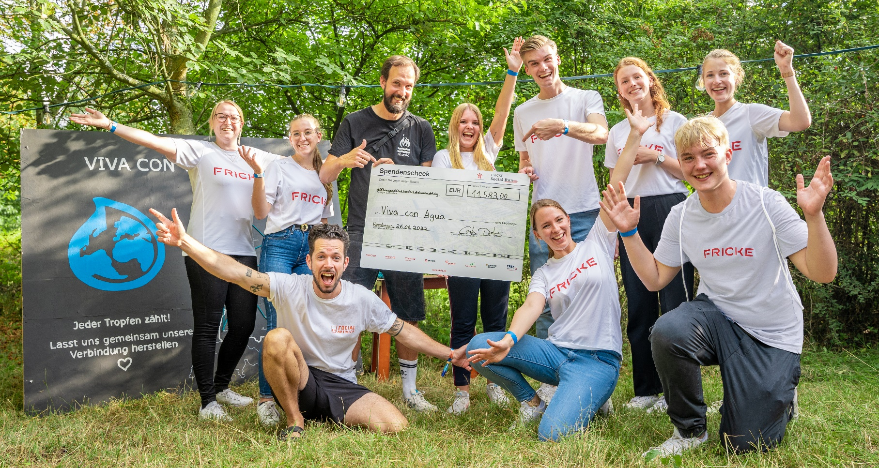
Submit charitable projects for consideration for the 2023 FRICKE Social Run now

The FRICKE Social Run is now in its fourth year. As part of this campaign, the FRICKE Group helps charitable organisations and clubs across Germany to implement projects close to their hearts. The final donation will be determined by the sporting achievements of the employees of the Heeslingen-based family business. Starting on Tuesday 9th May, clubs, nurseries, schools and other social or charitable organisations can apply for their project to receive one of the coveted donations. Applications can be submitted at socialrun.fricke.de.
Heeslingen, 15th May 2023 - As part of the FRICKE fördert initiative, the Heeslingen-based FRICKE Group has been supporting special projects implemented by charitable organisations across Germany for several years. The regional connection to their German locations is particularly important to the FRICKE Group. Organisations located within 30 kilometres of a company location are invited to apply.
This year's application phase for the FRICKE Social Run started on 9th May. Clubs and organisations can submit their social or charitable project for consideration up until 23rd May at socialrun.fricke.de. The projects chosen will receive a minimum donation of 500 euros, which will then be supplemented thanks to the sporting achievements of FRICKE Group employees.
FRICKE Social Run 2023 - How it works
Nurseries, schools, clubs and social or charitable organisations located within a 30 kilometre radius of one of the FRICKE Group's German locations can apply for the FRICKE Social Run. Applications can be submitted online from 9th to 23rd May at socialrun.fricke.de.
Online voting will be available from 24th May to 5th June via this link. Anyone can take part and vote for the project of their choice. Five projects are selected in this way, and two others with a particularly strong commitment to the common good each receive a wild card.
Organisations that won the previous year’s online vote or received a wild card cannot apply the following year. This ensures that the FRICKE Social Run supports as many different regional organisations as possible.
The projects chosen receive a fixed donation of 500 euros from the FRICKE Group. FRICKE Group employees can then increase this amount by taking part in the FRICKE Social Run. For every kilometre covered between 6th June and 4th July, another euro is added to the donation pot.
Versatile support
The FRICKE Social Run is also extremely popular with our colleagues outside Germany, which is why - in addition to seven German projects - the FRICKE Group is also supporting three European organisations. These were selected in advance by staff from our subsidiaries across Europe.
This year, employees can once again earn an extra euro for a global aid agency for every kilometre they cover. In the last two years, the FRICKE Group has made generous donations to Aktion Deutschland Hilft e.V. to support reconstruction efforts following the 2021 flood disaster, and to Viva con Agua for water projects in Uganda. In keeping with the motto “GROW. 100 years of growth”, WWF was chosen as this year’s global wild card on the occasion of the FRICKE Group’s 100th anniversary.
“This year, the FRICKE Social Run is all about sustainable growth. That’s why we’re supporting WWF’s rainforest conservation project in the Salonga National Park in the heart of the Congo Basin. We’re delighted that our sporting achievements are able to contribute to the preservation of one of the last primary rainforests in Africa and the world,” said Hans-Peter Fricke, Managing Director of the FRICKE Group, explaining why WWF was chosen.
Notes to the editors
Images can be found via the following link: https://we.tl/t-4zYfWVjBUn.
Image: Last year, Hamburg-based charity Viva con Agua e.V. was delighted to receive a generous donation.
Photo: © FRICKE Group

Press contact
FRICKE Group
Larissa Gabriel
Zum Kreuzkamp 7 · 27404 Heeslingen
Email: larissa.gabriel@fricke.de
Tel.: +49 (0)4281 712 7242
About the FRICKE Group
Founded in 1923, the FRICKE Group (www.fricke.de) is a successful international replacement parts wholesaler and agricultural machinery, commercial vehicle and garden technology supplier with a total of 67 locations in 26 countries. The owner-managed group of companies has its headquarters in the German town of Heeslingen, Lower Saxony, and employs 3470 full-time employees, 234 of whom are trainees.

